**1) 12-digit AWS ID: 790313363118**

**2) AWS Education Application Approval w/ $100 AWS Grant**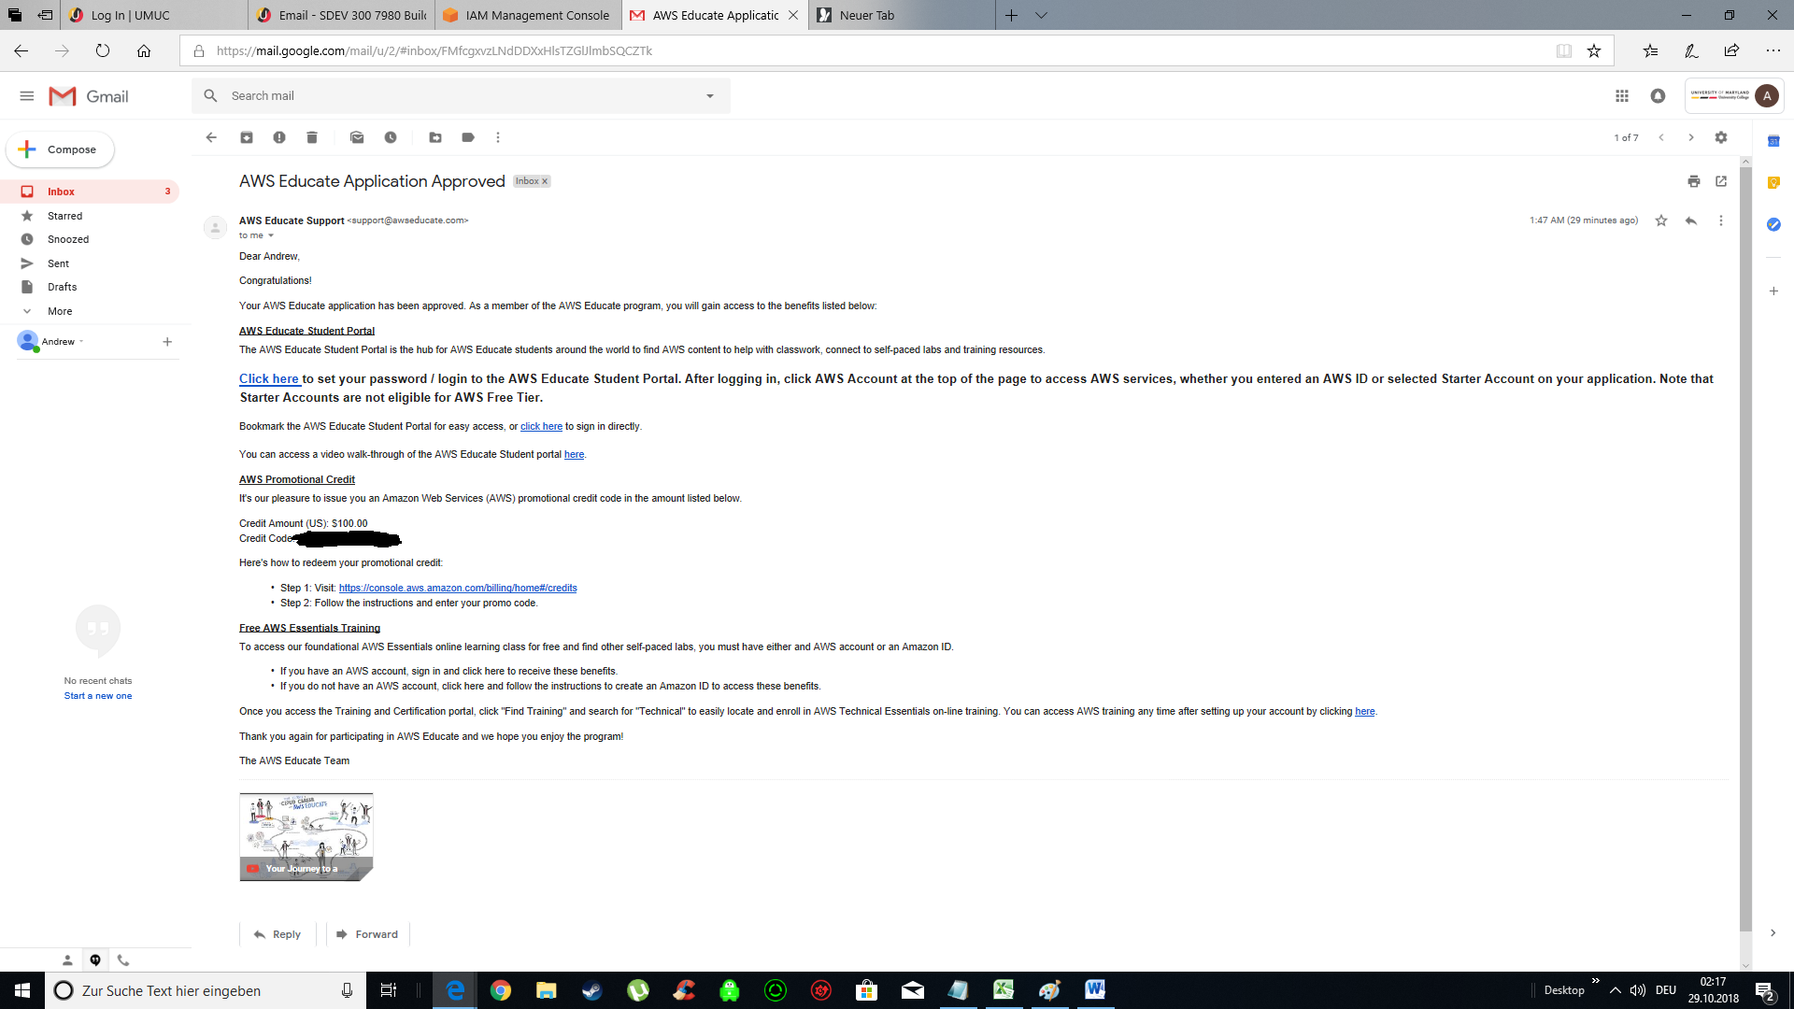

**3) 5 Security Best Practices w/ 12-digit AWS Number**